**VIVA IMR - Enters in the Intercollegiate League with “VICHAR MANTHAN”**

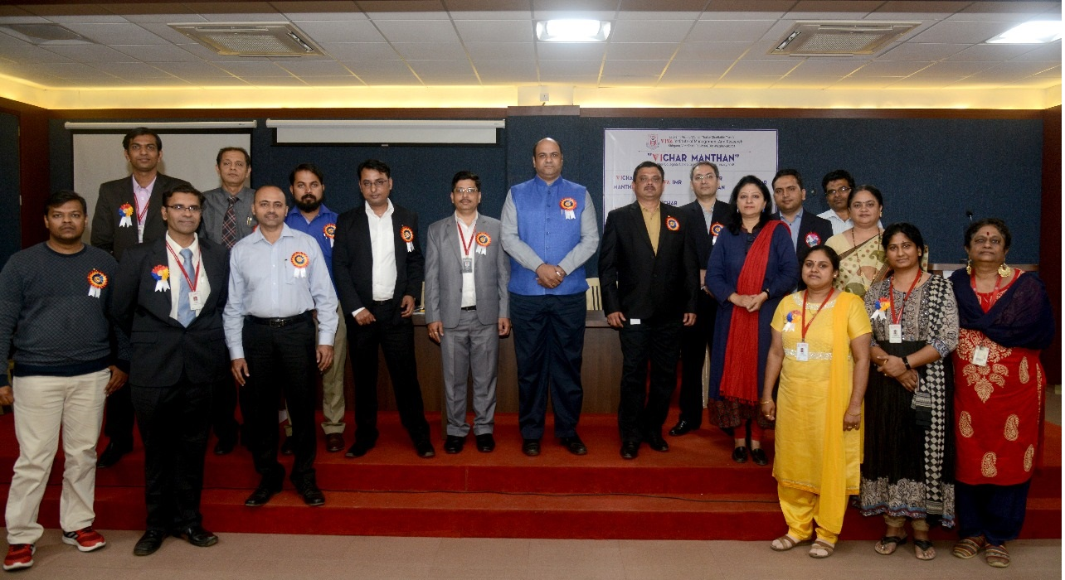

**VIVA Institute of Management and Research** arranged intercollegiate case study called **“Vichar Manthan”** event on Saturday 10th Feb 2018. A case study competition in which all Management Institution across Mumbai participated. More than 15 Management institute and Degree Colleges has participated and over 150+ students visited the campus for participating in the event.

The case study competition was basically for all the students such as Undergraduate (UG) as well as Post graduate (PG) mainly in three domains such as Finance, Marketing and Human Resource specialisation. For evaluation the judges from corporates were invited having more than over decade of experience such as Mr. Pavit Chadha, Associates Director, Julius Baer Wealth Advisors (India) Private Limited, Alok Shashank Oak, HR Head, Godrej & Boyce Mfg. Co. Ltd, Mr. Swarup Das, GM-HR, Kaya Ltd., Mr. Pankaj Jagtap, Sr. Manager HR, Aadhar Housing Finance Ltd., Mr. Sonu Agarwal, AVP & Branch Head, JM Financial Services Ltd., Mr. Amit Patil, DGM Marketing, Deepak Fertilizers & Petrochemical Ltd., and many more for evaluations.

The event started with high enthusiasm and which were still the same till the end of the day. As competition was on its highest peak. The best part of the event was that students across various colleges enjoyed and co-operated a lot and gave tough competition to each other. 

The evaluators for the day appreciated this event a lot and by the end of the day shared valuable experiences with students. All the winners for the case study competition got the trophy as well as certificate also all students coming for the event got a participation certificate as well.